**Chapter 1**

## **INTRODUCTION**

**OUTLINE:**

**1.1 Definition**

**1.2 Objectives**

**1.3 Justification of Study**

## **1.4 Scopes of Study**

## **1.5 Problem in Existing System**

## **1.6 System Attributes**

### 1.7 The challenge

### 1.8 The Solution

**1.9 The Benefits**

**1.1 Definition**

A dealership management system (DMS) or auto dealership management system may be a bundled management system created specifically for automotive business automobile dealer ships or massive instrumentality manufactures. The Dealer Management System is an integrated package. that takes care of each side of business method at business organization. The Dealer Management package (DMS) is meant to satisfy the wants of a contemporary business organization and facilitate dealer and company to figure additional expeditiously. It can provide better management information, and better support for customer-facing activities in both sales and after-sales services. Our DMS features easy-to-use, fully integrated modules to suit your dealership needs in accounting, sales, parts, service, spares and more. DMS is effectively a "lite" version of the systems which are used by automotive company and their dealers to manage their operations. Our aim is to deliver high returns on our clients investments maximize the value of our clients systems and process through creative use of our knowledge, skill. Our also aim to price our solutions and services competitively and deliver project within budget while continuously striving to reduce cost

## **1.2 Objectives**

The major objectives of this project are to design and simulation of a computerized dealership system. Moreover, few more objectives are there also. There are as follows-

* To design the record for stock and sales of a company into a computerized system.
* To develop various payment more sufficient and reliable.

## **1.3 Justification of Study**

Nowadays there are rapid changes in our society especially if we talk about computers and its technology. Automated dealership system is a system that automatically process sales activities, effectively, efficiently and with less of time consuming.

Base on the research the companies and organizations that currently using the manual dealership experience a lot of problem -

* The number of employees salary that need to be calculated its time consuming for payroll administrator.
* The accuracy of calculation is not guaranteed.
* The storage of documentation it can be easily damaged or lost.
* There is no guaranteed recovery’s of the information in case of building get fire.
* Data duplication can be occurred easily.

In this case the important thing to understand is that computerized system will do essentially the same functions as the existing manual system, only the methodology of performing the functions would change the input data will be the same. Similarly the output information of the new proposed system will be the same as in the current system. The difference will be the way the input is transformed into output. This transformation procedure in the system would be computerizing, hence efficient, accurate, reliable and better.

Our system is very secure to use because every time the user wants to access the system, the user has to insert the username and password. If one of the required information is invalid the system will not allow the user to access the systems functions. This is to make sure that unauthorized users don’t gain access to the system. Administrator doesn’t need to write or type the pay slip because there are automatically generated by the system. The system can produce report such as transaction, total stock report, purchase report, daily sales report, date wise (sales, stock, return)report and so on. This system able to minimize data entry and calculation the staffs pay, allowance, advance, deduction and others based on the formula rate.

This can improve data integrity and easier to save retrieve and manage those records. Our models provide many features that can solve the problems faced by the administrator like dealership function modules. All the problems with existing system are resolved in our system to justify the effort in terms of funds and time spent on operation.

## **1.4 Scopes of Study**

* Preparation and verification of salary and wage data
* Payroll calculation
* Delivery of reports: synoptic tables of benefits, retentions, contributions
* Financial interface with the accounting system
* Interface with banking applications and salary payment transactions.
* Payment of taxes and contributions to the treasury accounts.
* Standard reporting to the management.
* Legal reporting, including to the National Institute of Statistics.
* Complex reporting for your company’s needs.
* Employee consultant services relating to the calculation of employment rights, taxes and corresponding contributions.

## **1.5 Problem in Existing System**

The manual system are quite time consuming and less efficient and accurate in comparison

to the computerized system. So following are some disadvantages of the old system:

* Time consuming
* Less accuracy
* Less efficient database storage
* Great deal of paperwork
* Slow data processing
* Difficult to keep old records

## **1.6 System Attributes**

The system is done with following with following characteristics in mind:

* Ease of design to code translation
* Code efficiency
* Memory efficiency
* Faster Response time
* Maintainability
* Security
* Low cost

### 1.7 The challenge

* Centralized dealer management system for all seven dealer outlets
* Eliminate duplicated data, minimize sources of error
* Generate valid data for controlling at all times
* Bundle all processes relevant for customers
* Accelerate networking with BMW standard processes

### 1.8 The Solution

* MPLS (multiprotocol label switching) network between the dealer outlets
* Centralized dealer management system (DMS) BMW incadea engine
* Standardized customer and vehicle master in a single SQL database
* Interfaces to the service modules in the BMW main plant
* Rollout including employee training and service by T-Systems

**1.9 The Benefits**

* Automated parts ordering via interface to BMW
* Controlling reports and analyses in real time
* Solution certified and licensed by BMW
* Error rate falls from eight to under three percent
* Sales and service processes up to three times faster
* Other company sites can be integrated as required

# 

# CHAPTER 2

**METHODOLOGY**

**OUTLINE:**

**2.1 Description**

**2.2 Advantages of Waterfall Model**

**2.3 Disadvantages of Waterfall Model**

## **2.4 Justification of using Waterfall Model**

## **2.5 Phases of Waterfall Model**

Methodology is the process used to collection information and data for the purpose of making decisions. The methodology may include publication research, interviews, surveys and other research techniques and could include both present and historical information. In order to develop our project title is “Design and development of computerized dealership management system” We have used the waterfall model.

### 

Figure 1.1: Waterfall Model

## **2.1 Description:**

Waterfall model is referred to as a linear-sequential life cycle model.  It is very simple to understand and use.  In waterfall model, each phase must be completed fully before the next phase can begin. This type of model is basically used for the project which is small and there are no uncertain requirements. At the end of each phase, a review takes place to determine if the project is on the right path and whether or not to continue or discard the project. In this model the testing starts only after the development is complete. In waterfall model phases do not overlap.

## **2.2 Advantages of waterfall model:**

* This model is simple and easy to understand and use.
* In this model phases are processed and completed one at a time.

Phases do not overlap.

* Waterfall model works well for smaller projects where requirements are very well understood.

## **2.3 Disadvantages of waterfall model:**

* Once an application is in the testing stage, it is very difficult to go back and change something that was not well-thought out in the concept stage.
* High amounts of risk and uncertainty.
* Not a good model for complex and object-oriented projects.
* No working software is produced until late during the life cycle.

## **2.4** **Justification of Using Waterfall Model**

Every software developed is different and requires a suitable SDLC approach to be followed based on the internal and external factors. Some situations where the use of Waterfall model is most appropriate are:

* Requirements are very well documented, clear and fixed.
* Technology is understood and is not dynamic.
* The project is short.
* Simple and easy to understand and use
* Easy to arrange tasks.

## 

## **2.5 Phases of Waterfall Model**

* **Feasibility study**

The feasibility study activity involves the analysis of the problem and collection of the relevant information relating to the product. The main aim of the feasibility study is to determine whether it would be financially and technically feasible to develop the product.

* **Requirement analysis and specification**

The goal of this phase is to understand the exact requirements of the customer and to document them properly.(SRS)

* **Design**

The goal of this phase is to transform the requirement specification into a structure that is suitable for implementation in some programming language.

* **Implementation and unit testing**

During this phase the design is implemented. Initially small modules are tested in isolation from rest of the software product.

* **Integration and system testing**

In this all the modules are integrated and then tested altogether.

* **Operation and maintenance**

Release of software inaugurates the operation and life cycle phase of the operation. The phases always occur in this order and do not overlap.

# CHAPTER 3

**ANALYSIS, DESIGNING, DEVELOPMENT**

**OUTLINE:**

**3.1 Requirement Gathering technique**

**3.2 Analysis of requirement**

**3.3 Data flow diagram**

**3.4 Entity Relationship Diagram (ERD)**

## **3.5 Hardware requirements**

## **3.6 Software requirements**

### 3.7 Oracle 11 g database

### 3.8 Adobe reader

## **3.9 Toad**

### 3.10 Java

### 3.11 WEB LOGIN SERVER

### 3.12 WEBUTIL

# 

## **3.1 Requirement Gathering technique:**

Requirements gathering should be an iterative process; analysis and validation will lead to additional questions. The following elements we used to successful requirements gathering:

* Involve stakeholders throughout the process. They will help validate requirements and provide access to the relevant resources.
* Ensure that all requirements are measurable and can be traced back to business goals.
* Ensure that all requirements have an owner who can confirm that the requirement has been met.

## **3.2 Analysis of requirement**

Depending on the results of the initial investigation the survey is now expanded to a more detailed Analysis requirement. “ANALYSIS OF REQUIRENENT” is a test of system proposal according to its workability, impact of the organization, ability to meet needs and effective use of the resources. Therefore, the following considerations should be made in terms of the payroll function: the first is functions that manager need; the second is functions that the company’ employees need; and the third is functions needed by administrators while adding employees’ information and assessing their salary. It focuses on these major questions-

* The program accepts employee hours worked
* The program computes net pay
* The program record all the sales data for subsequent processing
* The program should prepare about sales return
* The program should prepare a stock ledger
* The program should maintain data on a sequential data backup file
* Non- statutory deductions such as union dues and pension plan to be made
* Year-to-date total should contain earnings, federal tax, Pension plan, and union dues
* data are total purchase, employee name, purchase rate, sales entry, sales return

## **3*.*3 Data flow diagram:**

Data flow Diagram (DFD) is a diagrammatical representation of the “flow” of data through an information system. It is a documentation aid which is understood by both programmers and nonprogrammers. A physical DFD specifies from where data flows and who processes the data and to whom the processed data is sent. In the blow we show our computerized dealer ship data flow diagram-

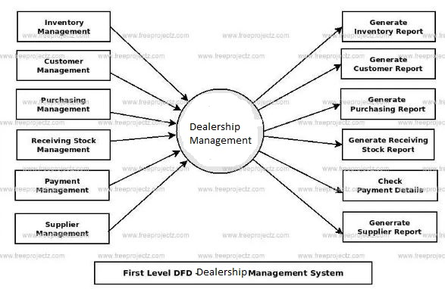

## 

## 

## **3.4 Entity Relationship Diagram (ERD)**

Our project ER diagram

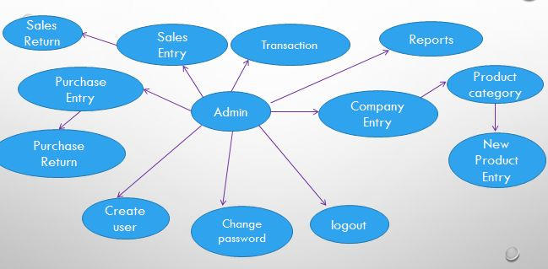

Figure1.2: Project ER Diagram

## **3.5 Hardware requirements:**

|  |  |  |
| --- | --- | --- |
| **SL** | **Hardware** | **Minimum System Requirement** |
| 01 | Processor | Intel Pentium 200 MHz minimum |
| 02 | Operating System | Windows OS- Windows XP Professional, Windows 7 Professional, Windows 10  Linux – Ubuntu, Read-Hat |
| 03 | Physical memory | 2 GB recommended |
|  | Virtual memory | Double the amount of RAM |
| 04 | Available Hard Disk Space | 1.5 GB |
| 05 | Attendance Device | Any type |

## **3.6 Software requirements:**

**Design:** oracle 6i developer

**Database-** oracle 11 g database**.**

**Language:** oracle dev.Suit (forms and report developer, PL-SQL, SQL)

**Additional Software–** web util configuration**,** toad, java, adobe reader, safari browser(you can use any browser).

**Server-**web logic server

## **3.7 Oracle 11 g database:**

Oracle database (Oracle DB) is a relational database management system (RDBMS) from the Oracle Corporation. Originally developed in 1977 by Lawrence Ellison and other developers, Oracle DB is one of the most trusted and widely-used relational database engines. The system is built around a relational database framework in which data objects may be directly accessed by users (or an application front end) through structured query language (SQL). Oracle is fully scalable relational database architecture and is often used by global enterprises, which manage and process data across wide and local area networks. The Oracle database has its own network component to allow communications across networks. Oracle DB is also known as Oracle RDBMS.

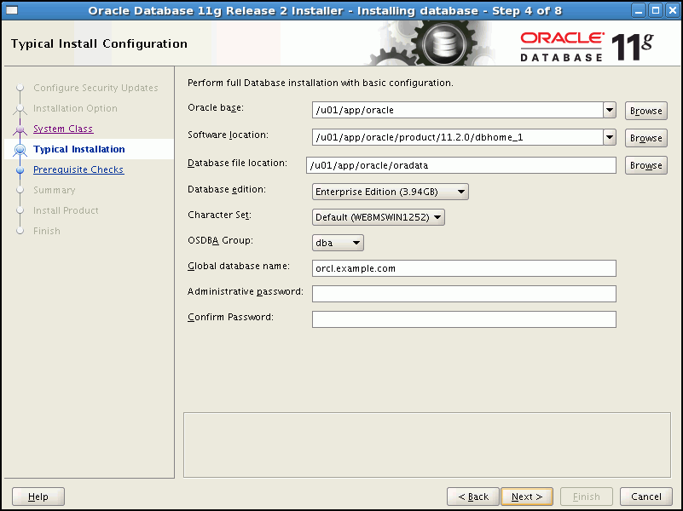

Figure1.3: Oracle database 11G

**Advantages of Using Oracle**

Oracle has many advantages and features that makes it popular and thereby makes it as the world’s largest enterprise software company. Oracle comes with new versions with new features implemented in new version while the features of earlier versions still being maintained. One important aspect is Oracle databases tend to be backwards compatible. Also when Oracle releases a new version, their documentation contains a list of all the features new to that version thus makes it user friendly for one to learn the new features.  Oracle is used for almost all large application and one of the main applications in which oracle takes its major presence is banking. One of the main advantage of oracle over other databases is in its recent version oracle has the concept of Flashback technology. Thus Flashback provides an

* Efficient recovery from human errors
* Faster database recovery
* Helps in simplifying the management and administration processes

## **3.8 Adobe reader:**

Adobe Acrobat is a family of application software and web services application software developed by adobe systems to view, create, manipulate, print and manage files in portable document format (PDF). Adobe was founded in February 1982[[4]](https://en.wikipedia.org/wiki/Adobe_Systems#cite_note-fastfacts-4) by john Warnock and Charles Geschke.

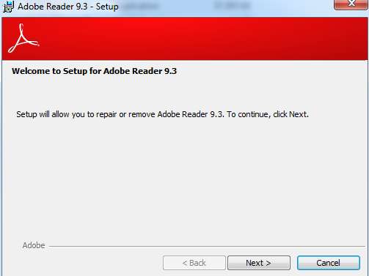

Figure 1.4: Adobe Reader

Oracle Applications Documentation is available electronically in Adobe Acrobat® format. Online HELP text for Release 11 is derived from the same user documentation and is available as HTML files. Hardcopy documentation is available for purchase from Media Services in Oracle Support.

## **3.9 Toad:**

Toad is a database management toolset from Quest Software that database developers, database administrators and data analysts use to manage both relational and non-relational databases using SQL. Jim McDaniel (aka "TOADman"), a practicing Oracle DBA, originally designed Toad for his own use in the late 1990s.[[2]](https://en.wikipedia.org/wiki/Toad_%28software%29#cite_note-2) He called it *Tool for Oracle Application Developers*: "TOAD" for short. McDaniel made the tool available to others first as shareware and later as freeware, distributing it freely over the Internet.



Figure 1.5: Toad For Oracle

Toad is now one of the best tools to develop and manage Oracle databases.  One of the major benefits Toad offers is, it reduces the effort and time you put into managing and maintaining Oracle databases.  It allows you to stay consistent with repeat processes while supporting an agile DB development.  You can easily resolve and pinpoint database issues.  Automation within Toad allows you to schedule routine and complex database .

## **3.1.0 Java:**

Java is a set of computer software and specifications developed by Sun Microsystems, which was later acquired by the Oracle Corporation that provides a system for developing application software and deploying it in a cross-platform computing environment.

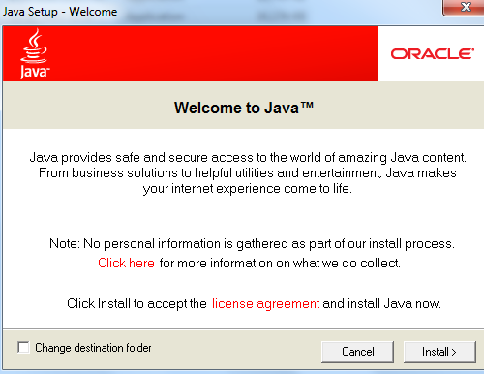

Figure 1.6: Java

The latest version is Java 8, the only supported (with e.g. security updates) version as of 2016. Oracle (and others) has announced that using older versions (than Java 8) of their JVM implementation presents serious risks due to unresolved security issues.

### 3.1.1 WEB LOGIN SERVER:

Oracle Web Logic Server 11G R2 is the industry's best application server for building and deploying enterprise Java EE applications with support for new features for lowering cost of operations, improving performance, enhancing scalability and supporting the Oracle Applications portfolio.

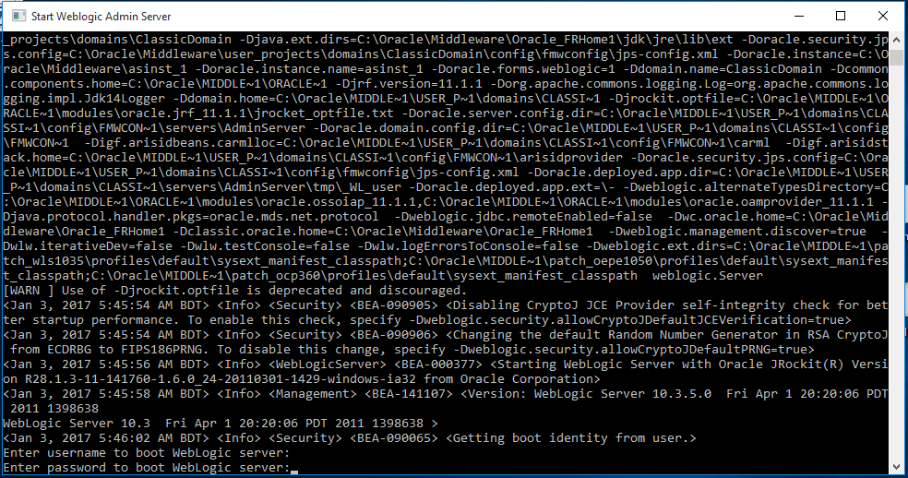

Figure 1.7: Web Login Server

### 3.1.2 WEBUTIL:

Web Util main purpose is to provide a simple way to achieve client side integration while running Oracle Forms on the web. It also simplifies the upgrade of existing applications to   
Web Util has an overriding goal to produce a utility that any Forms developer could use to carry out the complex tasks on the client browser machines by simply coding PL/SQL. With Web Util, everything the programmer needs to do is exposed through a PL/SQL library. Here we show some main of web util:

* Text_IO - Read and write text files on the client machine.
* Tool_Env - Read client side variables
* C API on the client - Interface with client side C.
* Host - Run Host commands on the client machine
* OLE2 - Integrate with client side OLE (e.g. Word and Excel)

# Chapter 4

## **IMPLEMENTATION**

**OUTLINE:**

**4.1 Interfaces**

**4.2 Overall Process Description**

## **4.3 Project Discussion**

**4.1. Interfaces**

Interfacing is the most important to workable any system. Interfacing means connecting between two or more part. Example: connecting between man and device, device and device, hardware and software, software and software etc. Only strong interfacing can give usable output. Same as our developed system have interfacing between man and system, front end and back end, module and module, client site and server site etc. At last, only interfacing can able to user friendly any system. We cannot consider of powerful system without interface.

## **4.2 Overall Process Description**

The Dealership Management Procedure minimizes inventory and costs of inventory ownership. The procedure ensures the best inventory practices are employed and align with overall company financial objectives and meet operational needs. It applies to all departments involved in managing inventories including the Finance, Accounting, Purchasing, Sales and Operations.

The purpose of dealership management is:

* To minimize and monitor inventory performance through metrics such as Days Inventory and Inventory Turns;
* To minimize and monitor Cost of Ownership;
* Ensure that inventory practices do not adversely affect the company’s financial performance; and
* Ensure that best inventory practices are employed and that they meet the company’s needs.

## **4.3. Project Discussion**

This is our application Login page. At first we use login this system. Hare tow type of logging access like admin and employee. When an admin user logging this system he can all module can operate. When an employ login this system he can use some of module whose is provided by admin.

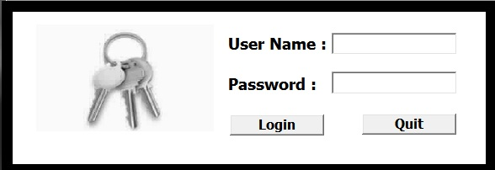

**Figure**1.8**: Login page**

**This is our application main page**



**Figure**1.9**: Main page**

**Database Backup**

Application database backup module. We can manual set location where. We can manual set location where backup database file is store.

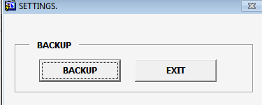

**Figure**1.10**: Backup Creation Page**

**Add New company**

Admin user can create new company by use this panel.

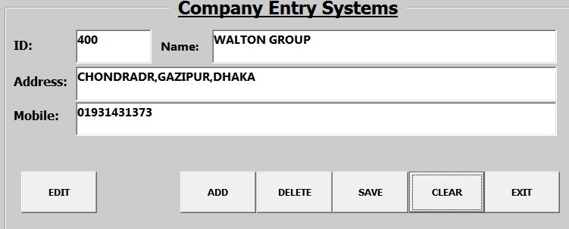

**Figure**1.11**: Company Entry page**

**Category Entry Page**

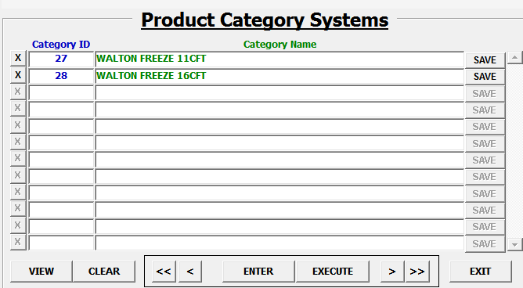

**Figure**1.12**: Product Category System**

**Product Entry Page**

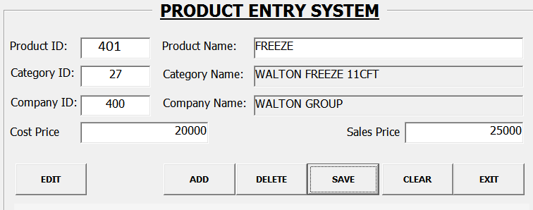

Figure1.13: Product Entry System

**Purchase Entry Page**

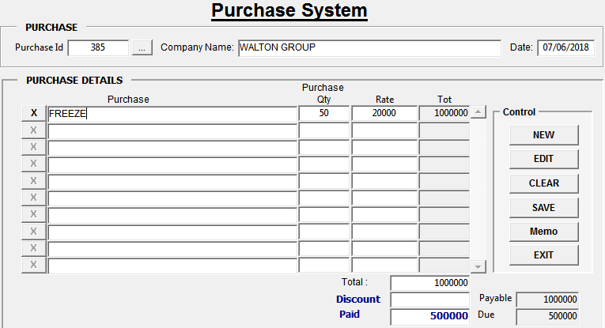

**Fig**1.14**: Purchase System**

**Purchase Return Page**

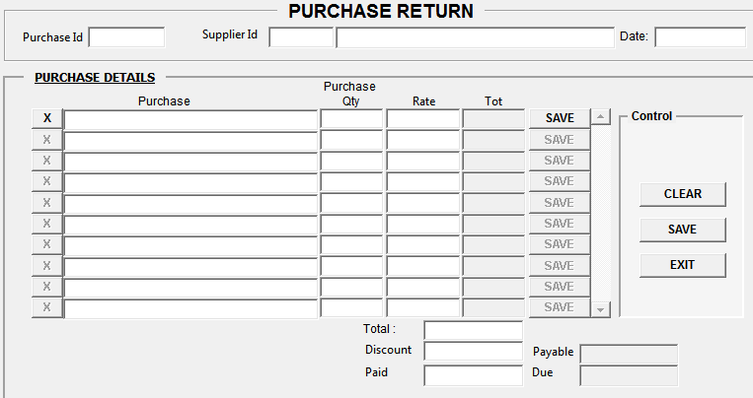

Fig1.15: Purchase Return System

**Sales Entry Page**

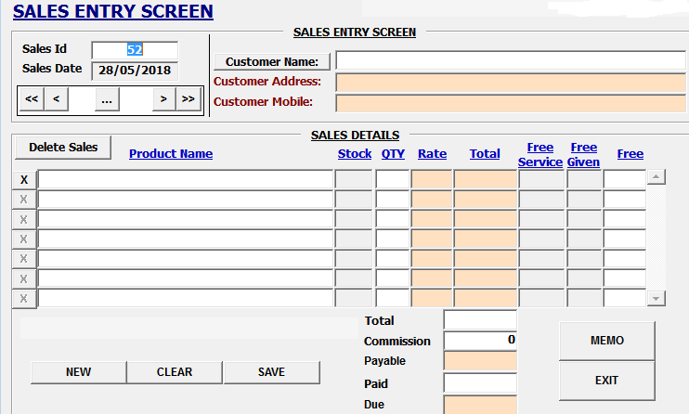

**Fig**1.16**: Sales Entry System**

**Sales Return Page**

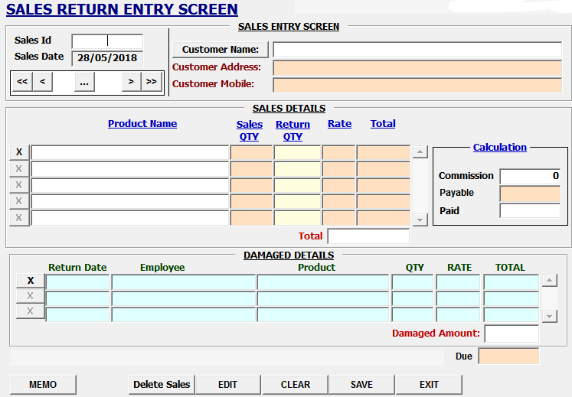

**Fig**1.17**: Sales Return System**

**Transaction Entry Page**

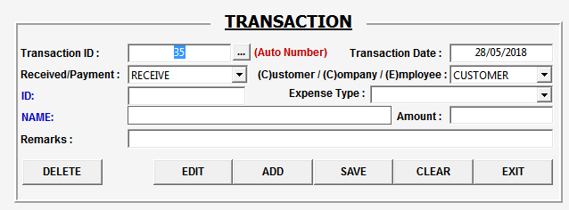

**Fig**1.18**: Transaction Entry System**

**Project Setting Parameter**

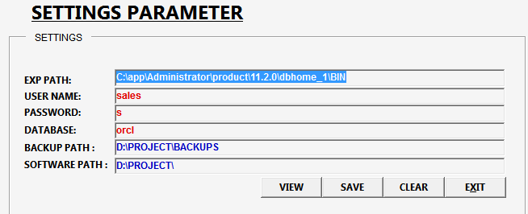

**Fig**1.19**: project Setting Parameter**

**Project Report System**

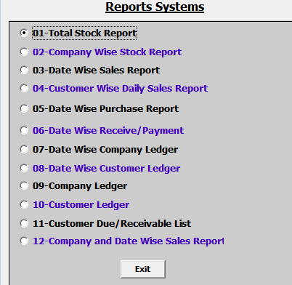

**Fig**2.0**: Project Report System**

# Chapter 5

# CONCLUSION

# 

**OUTLINE:**

**5.1 Future Development**

**5.2 Limitations**

# 

The system has an essential role to the accounting because it has a capability to automatically compute the total hours of work of every employee, deduction, gross pay and net pay of the employee. The system can generate daily report of employee’s attendance. The system can also print the outcome of the generated report, payroll report and pay slip report.

## **5.1 Future Development**

* More security ensures.
* More secure and convenient.
* More feature update.
* Make cloud-based payroll.

## **5.2 Limitations**

This software has some limitations which are mention are below.

* The system can only be access by authorized person.
* More expensive where need computer machine, accounting software.
* Needs an initial training for those who will maintain the payroll system.

**REFERSENCES**

1. Abu-Musa A (2005) Investigating the Perceived Threats of Computerized Accounting Information Sys-tems in Developing Countries: An Empirical Study on Saudi Organizations. Department of Accounting & MIS, KFUPM, Dhahran, Saudi Arabia.
2. Alkhatib Jamil, AnisMohab and Noori Hamid (2008) Open Source: the next big thing in the technolo-gy transfer to developing nations, International Association for Management of Technology.
3. Bannon Ryan, Chin Alvin, KassamFaryaaz and Roszko Andrew (2002) MySQL Conceptual Architec-ture Becker, Behavioral & Social Sciences Librarian 29: 301- 303.
4. Buczynski James A (2009) Online Web Development Platforms Enable All Reference Staff to Work on Subject Guides, Internet Reference Services Quarterly 14: 61-66.
5. Chang Yoon-Seop, Park Hyeong-Dong (2003) Development of a web-based Geographic Information System for the management of borehole and geological data. Computers & Geosciences 30: 887–897.
6. Chen Z (1999) Testing Client/Server Systems. The McGraw-Hills Compnies, Inc: 2-8.
7. DeelmanEwa, Singh Gurmeet, Atkinson P, Chervenak Ann , Chue Hong P, Kesselman Carl, PatilSonal, Pearlman Laura and Su [7]. Mei-Hui Grid-Based Metadata Services. Information Sciences Insti-tute, University of Southern California Department ofComputing Science, University of Glasgow & Division of Informatics, University of Edinburgh Edinburgh Parallel Computing Centre, UK.
8. Dokas M (2005) Developing Web Sites For Web Based Expert Systems.
9. Dongare Sanjay (2009) Powerful Utilization of Open Source Software in Digital Preservation, Main-tenance and Utilization: An Example of the Creation of Union Catalogue of Serials for Astronomy Li-braries in India. 7th International Caliber: 25-27.
10. Dumbrava Stefan, PanescuDoru and CostinMihaela (2005) A Three-tier Software Architecture for Manufacturing Activity Control in ERP Concept, International Conference on Computer Systems and Technologies.
11. Eldai Omer Ishag, Ali Ahmed Hassan M. H. and Raviraja S (2008) Towards a New Methodology for Developing Web-Based systems, *World* Academy of Science, Engineering and Technology 46.
12. Hunton J, Wright A and Wright S (2005) Business and Audit Risks Associated with ERP Systems.
13. MaharFaizullah (2003) Role of Information Technology in Transaction Processing. Information Tech-nology Journal 2: 128-34.
14. Miranda F J, Cortes R and Barriuso C (2006) Quantitative Evaluation of e-Banking Web Sites: an Em-pirical Study of Spanish Banks The Electronic Journal Information Systems Evaluation 9: 73 – 82.
15. Sutopo H (2010) Flash game with MySQL database development. Journal of Theoretical and Applied Information Technology.
16. Wang Rui, Chen Shuo, Wang XiaoFeng and QadeerShaz (2011) How to Shop for Free Online Securi-ty Analysis of Cashier-as-a-Service Based Web Stores. Indiana University Bloomington, Bloomington, IN, US